STRING PROGRAMS:
REVERSE STRING:
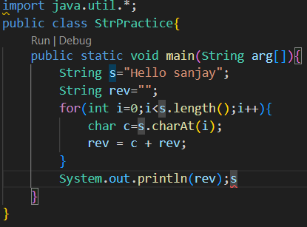
STRING IS A PALINDROME CHECK:
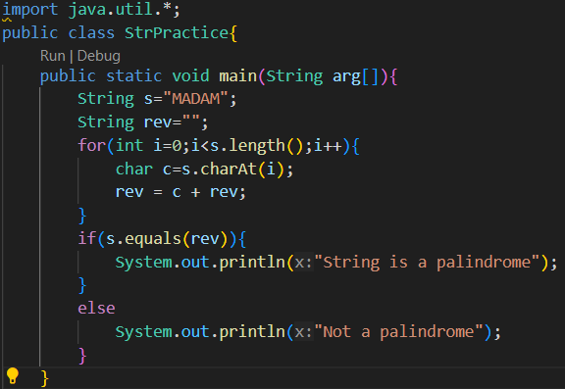

COUNT VOWELS AND CONSONANTS:
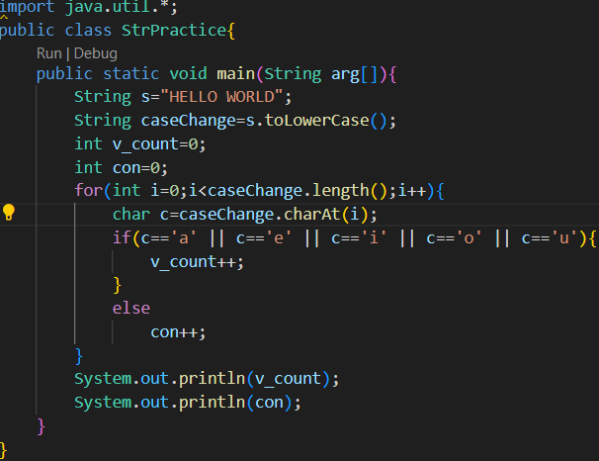
FREQUENCY OF CHARACTERS:
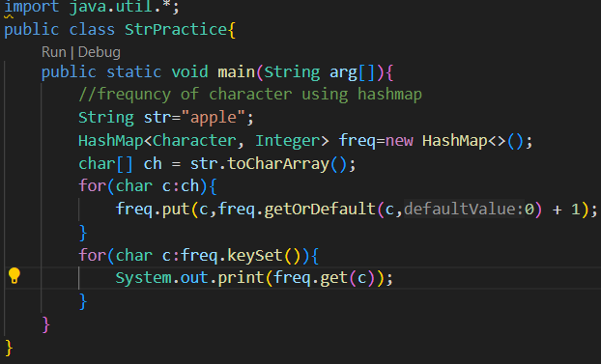
CONVERT TO UPPER AND LOWER CASE:
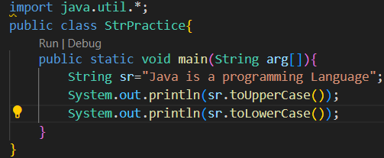
REMOVE WHITESPACE FROM A STRING:
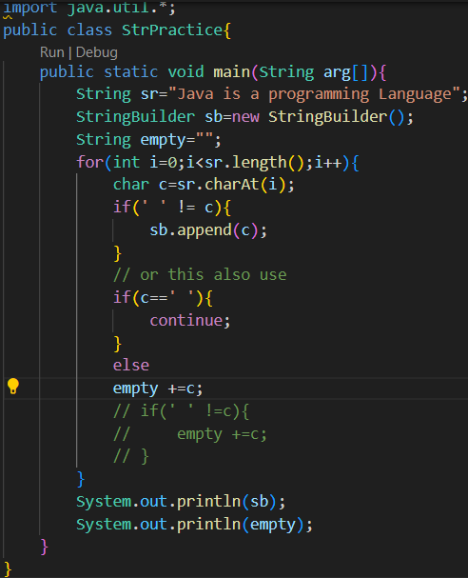
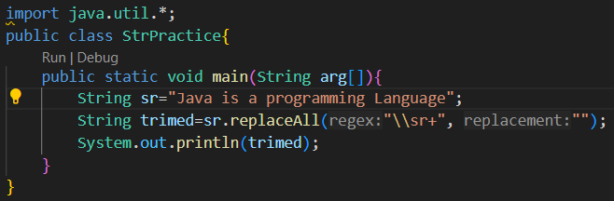

SUBSTRING OCCURENCES:
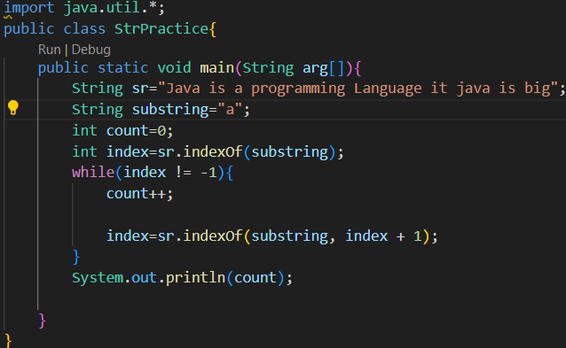

class Rectangle{
double length;
double width;

Rectangle(double l,double b){
this.length=l;
this.width=b;
}

double area(){
return length * width;
}

public void show(){
System.out.println(area());
}

}

class Student{
String name;
int rollNum;
int marks;

public Student(String n,int r,int m){
this.name=n;
this.rollNum=r;
this.marks=m;
}
boolean isPassed(){
if(marks>40){
return true;
}
else{
return false;
}
}
public void show(){
System.out.println(name);
System.out.println(rollNum);
System.out.println(marks);
System.out.println(isPassed());
}
}

class Employee{
int empId;
String empName;
double salary;

public Employee(int empId,String empName,double salary){
this.empId=empId;
this.empName=empName;
this.salary=salary;
}
public void displaydetails(){
System.out.println(empId);
System.out.println(empName);
System.out.println(salary);
}
}

class BankAccount{
int accNum;
String holderName;
double balance;

BankAccount(int acnum,String holName,double balance){
this.accNum=acnum;
this.holderName=holName;
this.balance=balance;
}
public double deposit(double amount){
if(amount>0){
balance +=amount;
}
return balance;
}
public double withdraw(double amount){
if(amount > 0 && amount <= balance ){
balance -=amount;
}
return balance;
}
public void result(){
System.out.println(accNum);
System.out.println(holderName);
System.out.println(balance);
}
}

class Book{
String title;
String author;
float price;

Book(String t,String a,float p){
this.title=t;
this.author=a;
this.price=p;
}
public void show(){
System.out.println(title);
System.out.println(author);
System.out.println(price);
}
}

class Circle{
double radius;
Circle(double r){
radius=r;
}
double calArea(){
return Math.PI * radius * radius;
}
double calCircumference(){
return 2 * Math.PI * radius;
}
public void res(){
System.out.println(calArea());
System.out.println((calCircumference()));
}
}

class Person{
String name;
int age;
Person(String n,int a){
this.name=n;
age=a;
}
boolean isAdult(){
if(age >= 18){
return true;
}
else{
return false;
}
}
}

class Calculator{
int a,b;
Calculator(int a,int b){
this.a=a;
this.b=b;
}

int add(){
return a+b;
}
int sub(){
return a-b;
}
int mul(){
return a*b;
}
int div(){
return a/b;
}
public void display(){
System.out.println(add());
System.out.println(sub());
System.out.println(mul());
System.out.println(div());
}
}

class Movie{
String title;
String genere;
double rating;

Movie(String t,String g,double rating){
this.title=t;
this.genere=g;
this.rating=rating;
}
public void show(){
System.out.println(title);
System.out.println(genere);
System.out.println(rating);
System.out.println();
}
}
public class Main {
public static void main(String ar[]){
Rectangle r1=new Rectangle(100,5);
r1.show();
System.out.println();
Student s=new Student("Rajkumar",21,50);
Student s1=new Student("vijaykumar",25,30);
s.show();
System.out.println();
s1.show();
System.out.println();
Employee e1=new Employee(1,"mohanbalaji",35984);
e1.displaydetails();
System.out.println();
BankAccount ba=new BankAccount(83572,"Monish kumar",500);
ba.result();
System.out.println(ba.deposit(200));
System.out.println(ba.withdraw(100));
System.out.println();
Book b=new Book("adbuk akhim","Librahir",990);
b.show();
System.out.println();
Circle cr=new Circle(5);
cr.res();
System.out.println();
Person p=new Person("balakumar",89);
System.out.println(p.isAdult());
System.out.println();
Calculator cal=new Calculator(20,10);
cal.display();
System.out.println();
Movie m1=new Movie("Kaki","sci-fic",5.4);
Movie m2=new Movie("kathi","comedy",6.4);
Movie m3=new Movie("gbu","action",5.7);
Movie m4=new Movie("thupakki","action",8.4);
if(m1.rating>6){
m1.show();
}
if(m2.rating>6){
m2.show();
}
if(m3.rating>6){
m3.show();
}
if(m4.rating>6){
m4.show();
}
}
}

Encpasulation:
class BankAcc{
private String accHolderName;
private String accnumber;
private double balance;

public String getAccHolderName(){
return accHolderName;
}
public String getAccnumber(){
return accnumber;
}
public double getBalance(){
return balance;
}
public void setAccHolderName(String name){
this.accHolderName=name;
}
public void setAccnumber(String accNum){
this.accnumber=accNum;
}

public void setBalance(double b){
if(b>=0)
this.balance=b;
}

public void deposit(double amt){
if(amt>0)
balance +=amt;
}

public void withdraw(double amt){
if(amt > 0 || amt<=balance){
balance -=amt;
}
}

public void show(){
System.out.println(accHolderName);
System.out.println(accnumber);
System.out.println(balance);
}
}

class Book{
private String title;
private String author;
private double price;

public String getTitle(){
return title;
}
public String getAuthor(){
return author;
}
public double getPrice(){
return price;
}
public void setTitle(String t){
this.title=t;
}
public void setAuthor(String au){
this.author=au;
}

public void setPrice(double p){
if(p>=0)
this.price=p;
}

public void show(){
System.out.println(title);
System.out.println(author);
System.out.println(price);
}
}

public class Main{
public static void main(String ar[]){
BankAcc ba=new BankAcc();
Book b=new Book();
ba.setAccHolderName("Mohan babu");
ba.setAccnumber("835602598345");
ba.setBalance(500);
ba.deposit(2000);
ba.withdraw(200);
ba.show();
b.setTitle("livingworth");
b.setAuthor("Jonhsen alhibhrim");
b.setPrice(1000);
System.out.println(b.getTitle());
b.show();
}
}

TOP 30 QUESTIONS :

11. Find the GCD (Greatest Common Divisor) of two numbers

Required Input:
8, 12

Expected Output:
4

public class Main {
public static void main(String ar[]){
System.out.println(findGCD());
}
public static int findGCD() {
int a = 8;
int b = 12;
while(b !=0){
int temp = b;
b=a % b;
a=temp;
}
// Your code here
return a;
}
}

12. Find the LCM (Least Common Multiple) of two numbers

Required Input:
4, 5

Expected Output:
20

public class Main {
public static void main(String ar[]){
System.out.println(findLCM());
}
public static int findLCM() {
int a = 4;
int b = 5;

return (a * b)/findGCD(a,b);
}
public static int findGCD(int a,int b) {
while(b !=0){
int temp = b;
b=a % b;
a=temp;
}
return a;
}
}

13. Check if a number is prime

Required Input:
7

Expected Output:
true
public class Main {
public static void main(String ar[]){
System.out.println(isPrime());
}
public static boolean isPrime() {
int n = 7;
if(n<=1)
{
return false;
}
for(int i=2;i<=Math.sqrt(n);i++){
if(n % i==0){
return false;
}
}
return true;
}
}

14. Find the length of the longest word in a sentence

Required Input:
Java programming is fun

Expected Output:
11

public class Main {
public static void main(String ar[]){
System.out.println(longestWordLength());
}
public static int longestWordLength() {
String sentence = "Java programming is fun";
String[] words=sentence.split("\\s+");
int maxlength=0;
for(String word:words)
{
maxlength=Math.max(maxlength,word.length());
}
return maxlength;
}
}

15. Convert a list of strings to uppercase

Required Input:
["java", "python", "cpp"]

Expected Output:
[JAVA, PYTHON, CPP]

import java.util.*;

public class Main {
public static void main(String ar[]){
System.out.println(toUpperCase());
}
public static List<String> toUpperCase() {
List<String> lst = Arrays.asList("java", "python", "cpp");
List<String> res=new ArrayList<>();
for(String s:lst){
res.add(s.toUpperCase());
}
return res;
}
}

16. Remove duplicates from a list of integers

Required Input:
[1, 2, 2, 3, 3, 3, 4]

Expected Output:
[1, 2, 3, 4]
import java.util.*;

public class Main {
public static void main(String ar[]){
System.out.println(removeDuplicates());
}
public static List<Integer> removeDuplicates() {
List<Integer> lst = Arrays.asList(1, 2, 2, 3, 3, 3, 4);
// Your code here
HashSet<Integer> hs=new HashSet<>();
for(int n:lst){
hs.add(n);
}
return new ArrayList<>(hs);

// List<Integer> lst = Arrays.asList(1, 2, 2, 3, 3, 3, 4);
// Set<Integer> uniqueSet = new HashSet<>(lst);
// return new ArrayList<>(uniqueSet);
}
}

17. Sort a list of integers in ascending order

Required Input:
[5, 3, 8, 1, 2]

Expected Output:
[1, 2, 3, 5, 8]

import java.util.*;

public class Main {
public static void main(String ar[]){
System.out.println(sortList());
}
public static List<Integer> sortList() {
List<Integer> lst = Arrays.asList(5, 3, 8, 1, 2);
int n=lst.size();
for(int i=0;i<n-1;i++){
for(int j=i+1;j<n;j++){
if(lst.get(i)>lst.get(j)){
//swap
int temp=lst.get(i);
lst.set(i,lst.get(j));
lst.set(j,temp);
}
}
}
return new ArrayList<>(lst);
// collections.sort(lst);
}
}

18. Find the common elements in two lists

Required Input:
[1, 2, 3, 4], [3, 4, 5, 6]

Expected Output:
[3, 4]

import java.util.*;

public class Main {
public static void main(String ar[]){
List<Integer> res=commonElements();
System.out.println(res);
}
public static List<Integer> commonElements() {
List<Integer> lst1 = Arrays.asList(1, 2, 3, 4);
List<Integer> lst2 = Arrays.asList(3, 4, 5, 6);
HashMap<Integer,Integer> m1=new HashMap<>();
List<Integer> common=new ArrayList<>();
for(int n:lst1){
m1.put(n,m1.getOrDefault(n,0)+1);
}
for(int num:lst2){
if(m1.containsKey(num)){
common.add(num);
}
}
return common;
}
}

19. Check if two strings are anagrams

Required Input:
listen, "silent"

Expected Output:
true

import java.util.*;

public class Main {
public static void main(String ar[]){
System.out.println(areAnagrams());
}
public static boolean areAnagrams() {
String s1 = "listen";
String s2 = "silent";
// Your code here
//1.convert array
char[] c1=s1.toCharArray();
char[] c2=s2.toCharArray();
//2.sort the array
Arrays.sort(c1);
Arrays.sort(c2);
//3.to check array are equal or not
return Arrays.equals(c1,c2);
}
}

20. Find the intersection of two sets

Required Input:
{1, 2, 3}, {3, 4, 5}

Expected Output:
[3]
import java.util.*;

public class Main {
public static void main(String ar[]){
System.out.println(findIntersection());
}
public static Set<Integer> findIntersection() {
Set<Integer> set1 = new HashSet<>(Arrays.asList(1, 2, 3));
Set<Integer> set2 = new HashSet<>(Arrays.asList(3, 4, 5));
//In collections in java retainAll() method helps us to find common elements
set1.retainAll(set2);
return set1;
}
}

Remaining program:
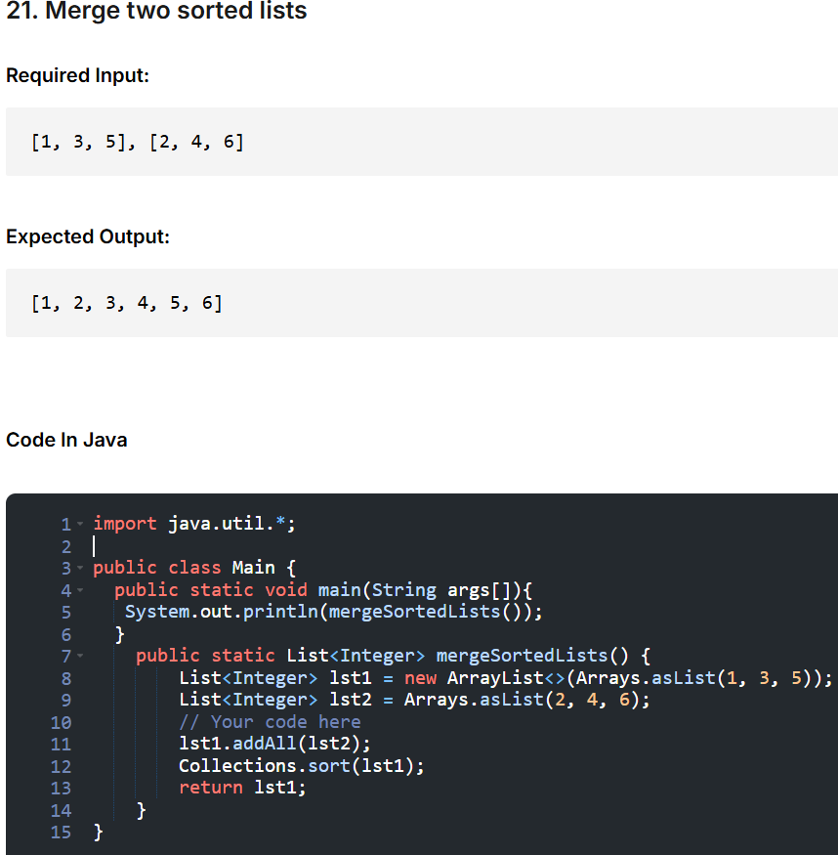

22. Find the most frequent element in a list

Required Input:
[1, 2, 3, 3, 2, 2]

Expected Output:
2
import java.util.*;

public class Main {
public static void main(String args[]){
System.out.println(mostFrequentElement());
}
public static int mostFrequentElement() {
List<Integer> lst = Arrays.asList(1, 2, 3, 3, 2, 2);
// Your code here
HashMap<Integer,Integer> map=new HashMap<>();
for(int n:lst){
map.put(n,map.getOrDefault(n,0)+1);
}
int maxcount=0;
int mostFreq=lst.get(0);
//Find the key with the highest frequency
for(Map.Entry<Integer,Integer> entry:map.entrySet()){
if(entry.getValue()>maxcount){
maxcount=entry.getValue();
mostFreq=entry.getKey();
}
}

return mostFreq;
}
}

23. Flatten a nested list

Required Input:
[[1, 2], [3, 4], [5, 6]]

Expected Output:
[1, 2, 3, 4, 5, 6]
import java.util.*;

public class Main {
public static void main(String args[]){
System.out.println(flattenList());
}
public static List<Integer> flattenList() {
List<List<Integer>> nestedList = Arrays.asList(
Arrays.asList(1, 2),
Arrays.asList(3, 4),
Arrays.asList(5, 6)
);
// Your code here
List<Integer> list=new ArrayList<>();
for(List<Integer> sublist:nestedList){
list.addAll(sublist);
}
return list;
}
}

24. Calculate the sum of digits of a number

Required Input:
123

Expected Output:
6
public class Main {
public static void main(String args[]){
System.out.println(sumOfDigits());
}
public static int sumOfDigits() {
int n = 123;
// Your code here
int sum=0;
while(n !=0){
int rem=n % 10;
sum +=rem;
n /=10;

}
return sum;
}
}

25. Find the transpose of a matrix

Required Input:
[[1, 2], [3, 4]]

Expected Output:
[[1, 3], [2, 4]]
import java.util.*;

public class Main {
public static void main(String args[]){
int[][] ans=transposeMatrix();
System.out.println(Arrays.deepToString(ans));
}
public static int[][] transposeMatrix() {
int[][] matrix = {
{1, 2},
{3, 4}
};
// Your code here
int[][] res=new int[2][2];
for(int i=0;i<2;i++){
for(int j=0;j<2;j++){
res[j][i]=matrix[i][j];
}
}
return res;
}
}

26. Remove all occurrences of a specified element from a list

Required Input:
[1, 2, 3, 2, 4], 2

Expected Output:
[1, 3, 4]
import java.util.*;

public class Main {
public static void main(String args[]){
System.out.println(removeElement());
}
public static List<Integer> removeElement() {
List<Integer> lst = Arrays.asList(1, 2, 3, 2, 4);
int element = 2;
// Your code here
List<Integer> list=new ArrayList<>();
for(int n:lst){
if( n!=element){
list.add(n);
}
}
return list;
}
}

27. Find the second smallest number in a list

Required Input:
[4, 3, 1, 2]

Expected Output:
2
import java.util.*;

public class Main {
public static void main(String args[]){
System.out.println(secondSmallest());
}
public static int secondSmallest() {
List<Integer> lst = Arrays.asList(4, 3, 1, 2);
// Your code here
int min=lst.get(0);
for(int n:lst){
if(n<min){
min=n;
}
}
int secMin=lst.get(0);
for(int i=0;i<lst.size();i++){
if(lst.get(i)<secMin && lst.get(i) != min){
secMin=lst.get(i);
}
}
return secMin;
}
}

28. Check if a number is a perfect square

Required Input:
25

Expected Output:
true
public class Main {
public static void main(String args[]){
System.out.println(isPerfectSquare());
}
public static boolean isPerfectSquare() {
int n = 25;
// Your code here
double num=Math.sqrt(n);

return num==(int) num;
}
}

29. Find the sum of even numbers in a list

Required Input:
[1, 2, 3, 4, 5]

Expected Output:
6
import java.util.*;

public class Main {
public static void main(String args[]){
System.out.println(sumOfEven());
}
public static int sumOfEven() {
List<Integer> lst = Arrays.asList(1, 2, 3, 4, 5);
// Your code here
int sum=0;
for(int n:lst){
if(n % 2==0){
sum +=n;
}
}
return sum;
}
}

30. Rotate a list to the right by k positions

Required Input:
[1, 2, 3, 4, 5], 2

Expected Output:
[4, 5, 1, 2, 3]
import java.util.*;

public class Main {
public static void main(String[] args) {
System.out.println(rotateList());
}
public static List<Integer> rotateList() {
List<Integer> lst = Arrays.asList(1, 2, 3, 4, 5);
int k = 2;
// Your code here
Collections.rotate(lst,k);
return new ArrayList<>(lst);
}
}

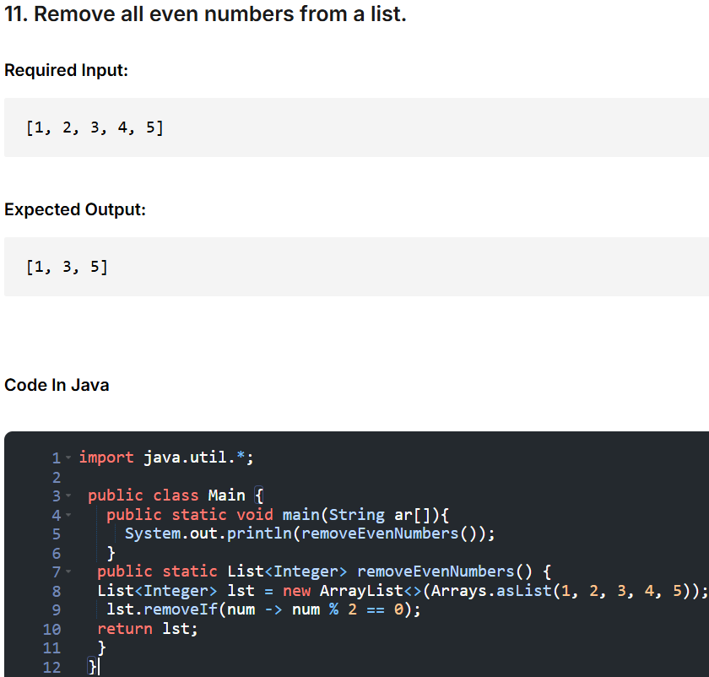

12. Find the maximum product of two numbers in an array.
import java.util.*;

public class Main {
public static void main(String ar[]){
System.out.println(maxProduct());
}
public static int maxProduct() {
int[] arr = {1, 2, 3, 4, 5};
// Your code here
int currprod=1;
int maxprod=1;
for(int i=0;i<arr.length-1;i++){
currprod=1;
for(int j=i+1;j<arr.length;j++){
int prod = arr[i] * arr[j];
if(currprod < prod){
currprod=prod;
}
}
maxprod=Math.max(maxprod,currprod);
}

return maxprod;
}
}

13. Find the common elements in three lists.

Required Input:
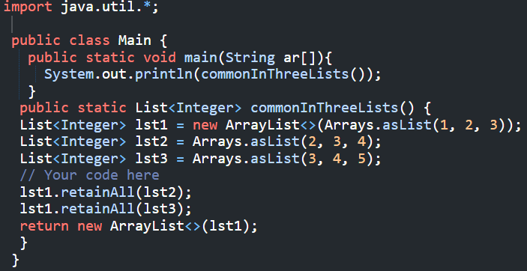

14. Find the missing number in an array from 1 to n.
import java.util.*;
public class Main {
public static void main(String ar[]){
System.out.println(findMissingNumber());
}
public static int findMissingNumber() {
int[] arr = {1, 2, 4, 5};
int n = 5;
// Your code here
//cal expected sum of numbers from 1 to n == n*(n + 1)/2
//cal actual sum of array
//cal diff b/w them
int total=n * (n + 1)/2;
int acutalSum=0;
for(int i: arr){
acutalSum +=i;
}
return total-acutalSum;
}
}

15. Find all pairs in an array that sum to a target value.
import java.util.*;
public class Main {
public static void main(String ar[]){
System.out.println(findPairs());
}

public static List<List<Integer>> findPairs() {
int[] arr = {1, 2, 3, 4, 5};
int target = 5;
// Your code here
List<List<Integer>> res=new ArrayList<>();
HashSet<Integer> h=new HashSet<>();
for(int i: arr){
int complement=target-i;
//check if complement is already in the set
if(h.contains(complement)){
//add pairs of [complement,i]
res.add(Arrays.asList(complement,i));
}
h.add(i);
}
return new ArrayList<>(res);
}
}

16. Remove duplicates from a string while maintaining the order of characters.
import java.util.*;
public class Main {
public static void main(String ar[]){
System.out.println(removeDuplicates());
}
public static String removeDuplicates() {
String str = "programming";
// Your code here
//string to chararray (convert)
//use a hashset to track characters already seen
//only append characters that are not already in the set
StringBuilder sb=new StringBuilder();
HashSet<Character> h=new HashSet<>();
for(char ch:str.toCharArray()){
if(!h.contains(ch)){ // check in hashset
h.add(ch);
sb.append(ch); //adding
}
}

// This is unorder so that above code used
// for(char ch:str.toCharArray()){
// h.add(ch);
// }
// for(char cha:h){
// sb.append(cha);
// }

return sb.toString();
}
}

/******************************************************************************

Online Java Compiler.
Code, Compile, Run and Debug java program online.
Write your code in this editor and press "Run" button to execute it.

*******************************************************************************/
import java.util.*;
class Person{
private String name;
private int age;
public Person(String name,int age){
this.name=name;
this.age=age;
}
public String getName(){
return name;
}
public void setName(String name){
this.name=name;
}
public int getAge(){
return age;
}
public void setAge(int age){
if(age>0){
this.age=age;
}
}
}
class Student extends Person{
private String stu_id;
public Student(String name,int age,String stu_id){
super(name,age);
this.stu_id=stu_id;
}
public String getStudent(){
return stu_id;
}
public void setStudent(String stu_id){
this.stu_id=stu_id;
}
public void display(){
System.out.println(getName());
System.out.println(getAge());
System.out.println(getStudent());
}
}
class Employee extends Person{
private String empId;
private double salary;
public Employee(String name,int age,String empId,double salary){
super(name,age);
this.empId=empId;
this.salary=salary;
}
public String getEmpId(){
return empId;
}
public void setEmpId(String empId){
this.empId=empId;
}
public double getSalary(){
return salary;
}
public void setSalary(double salary){
if(salary>0){
this.salary=salary;
}
}
public void display(){
System.out.println(getName());
System.out.println(getAge());
System.out.println(getEmpId());
System.out.println(getSalary());
}

}
public class Main
{
public static void main(String[] args) {
System.out.println("Hello World");
Student s1=new Student("Santhosh",12,"stu123");
s1.display();
s1.setName("Smaith");
s1.setAge(13);
s1.setStudent("stu124");
System.out.println("Updated name" + " " + s1.getName());
System.out.println("Updated age" + " " + s1.getAge());
System.out.println("Updated id" + " " + s1.getStudent());
System.out.println();
System.out.println();
Employee e1=new Employee("Balaji Mohan",20,"emp12",30000.0);
e1.display();
e1.setName("John kumar");
e1.setAge(15);
e1.setEmpId("emp14");
e1.setSalary(35000.0);
System.out.println("Updated name" + " " + e1.getName());
System.out.println("Updated age" + " " + e1.getAge());
System.out.println("Updated empid" + " " + e1.getEmpId());
System.out.println("Updated salary" + " " + e1.getSalary());

}
}

Linked List Revise topics:
// Online Java Compiler
// Use this editor to write, compile and run your Java code online
class Node{
int data;
Node next;
Node(int data){
this.data=data;
this.next=null;
}
}
class Linkedlist{
static Node arrList(int[] arr){
if(arr.length==0){
return null;
}
Node head=new Node(arr[0]);
Node t=head;
for(int i=1;i<arr.length;i++){
t.next=new Node(arr[i]);
t=t.next;
}
return head;
}
static void prin(Node head){
Node t=head;
while(t != null){
System.out.print(t.data + "--->");
t=t.next;
}
}
static Node removeHead(Node head){
if(head==null){
return head;
}
head=head.next;
return head;
}
static Node removeTail(Node head){
if(head==null || head.next==null){
return null;
}
Node temp=head;
while(temp.next.next !=null){
temp=temp.next;
}
temp.next=null;
return head;
}
static Node removeKthPosition(Node head,int k){
if(head==null || k<=0){
return head;
}
if(k==1){
head=head.next;
return head;
}
Node temp=head;
Node prev=null;
int count=0;
while(temp !=null){
count++;
if(count==k){
prev.next=prev.next.next;
break;
}
prev=temp;
temp=temp.next;
}
return head;
}
static Node removeElementValue(Node head,int value){
if(head==null){
return head;
}
if(head.data==value){
head=head.next;
return head;
}
Node temp=head;
Node prev=null;
while(temp !=null){
if(temp.data==value){
prev.next=temp.next;
break;
}
prev=temp;
temp=temp.next;
}
return head;
}
}
class Main {
public static void main(String[] args) {

int[] arr={10,40,20,30,80,60,45,34,23,12,90};
Node head=Linkedlist.arrList(arr);
Linkedlist.prin(head);
System.out.println();

head=Linkedlist.removeHead(head);
Linkedlist.prin(head);
System.out.println();

head=Linkedlist.removeTail(head);
Linkedlist.prin(head);
System.out.println();

head=Linkedlist.removeKthPosition(head,2);
Linkedlist.prin(head);
System.out.println();

head=Linkedlist.removeElementValue(head,45);
Linkedlist.prin(head);
System.out.println();
}
}
OUTPUT:
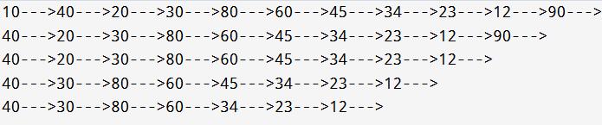

import java.util.*;
class Node{
int val;
Node next;
Node(int val){
this.val=val;
this.next=null;
}
}
class LL{
static Node arrayList(int[] arr){
if(arr.length==0){
return null;
}
Node head=new Node(arr[0]);
Node temp=head;
for(int i=1;i<arr.length;i++){
temp.next=new Node(arr[i]);
temp=temp.next;
}
return head;
}
static void print(Node head){
Node t=head;
while(t !=null){
System.out.print(t.val+"-->");
t=t.next;
}
}
}
public class Main
{
public static void main(String[] args) {
int[] arr={2,4,2,5,8,9};
LL li=new LL();
Node head=li.arrayList(arr);
li.print(head);

}
}

